Adjective as an Object Complement

✅ What Is an Adjective as an Object Complement?
# Source: AI Source: Provided by: [Data Path: Persons Table -> ID Column: 1, Name_En Column: Motasem Essam] -> From: [ChatGPT] on [8/4/2025]
An** adjective used as an object complement follows the direct object and describes or qualifies it. It tells what the object becomes or how it is perceived after the action of the verb.

🔸 Key Features:
# Source: AI Source: Provided by: [Data Path: Persons Table -> ID Column: 1, Name_En Column: Motasem Essam] -> From: [ChatGPT] on [8/4/2025]
- Comes after a direct object
- Describes the state or condition of the object
- Often follows verbs like:
  - make, find, consider, paint, name, call, keep, drive

🔸 Examples of Adjective Object Complements:
# Source: AI Source: Provided by: [Data Path: Persons Table -> ID Column: 1, Name_En Column: Motasem Essam] -> From: [ChatGPT] on [8/4/2025]
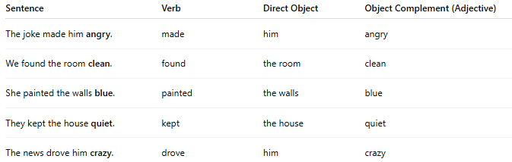
Sentence | Verb | Direct Object | Object Complement (Adjective)
The joke made him angry. | made | him | angry
We found the room clean. | found | the room | clean
She painted the walls blue. | painted | the walls | blue
They kept the house quiet. | kept | the house | quiet
The news drove him crazy. | drove | him | crazy

🔸 How to Identify:
# Source: AI Source: Provided by: [Data Path: Persons Table -> ID Column: 1, Name_En Column: Motasem Essam] -> From: [ChatGPT] on [8/4/2025]
Ask:
- “What did the joke make him?” → Angry
- “What did they find the room?” → Clean
If the word after the object describes the resulting state or condition of the object, it’s an adjective object complement.

